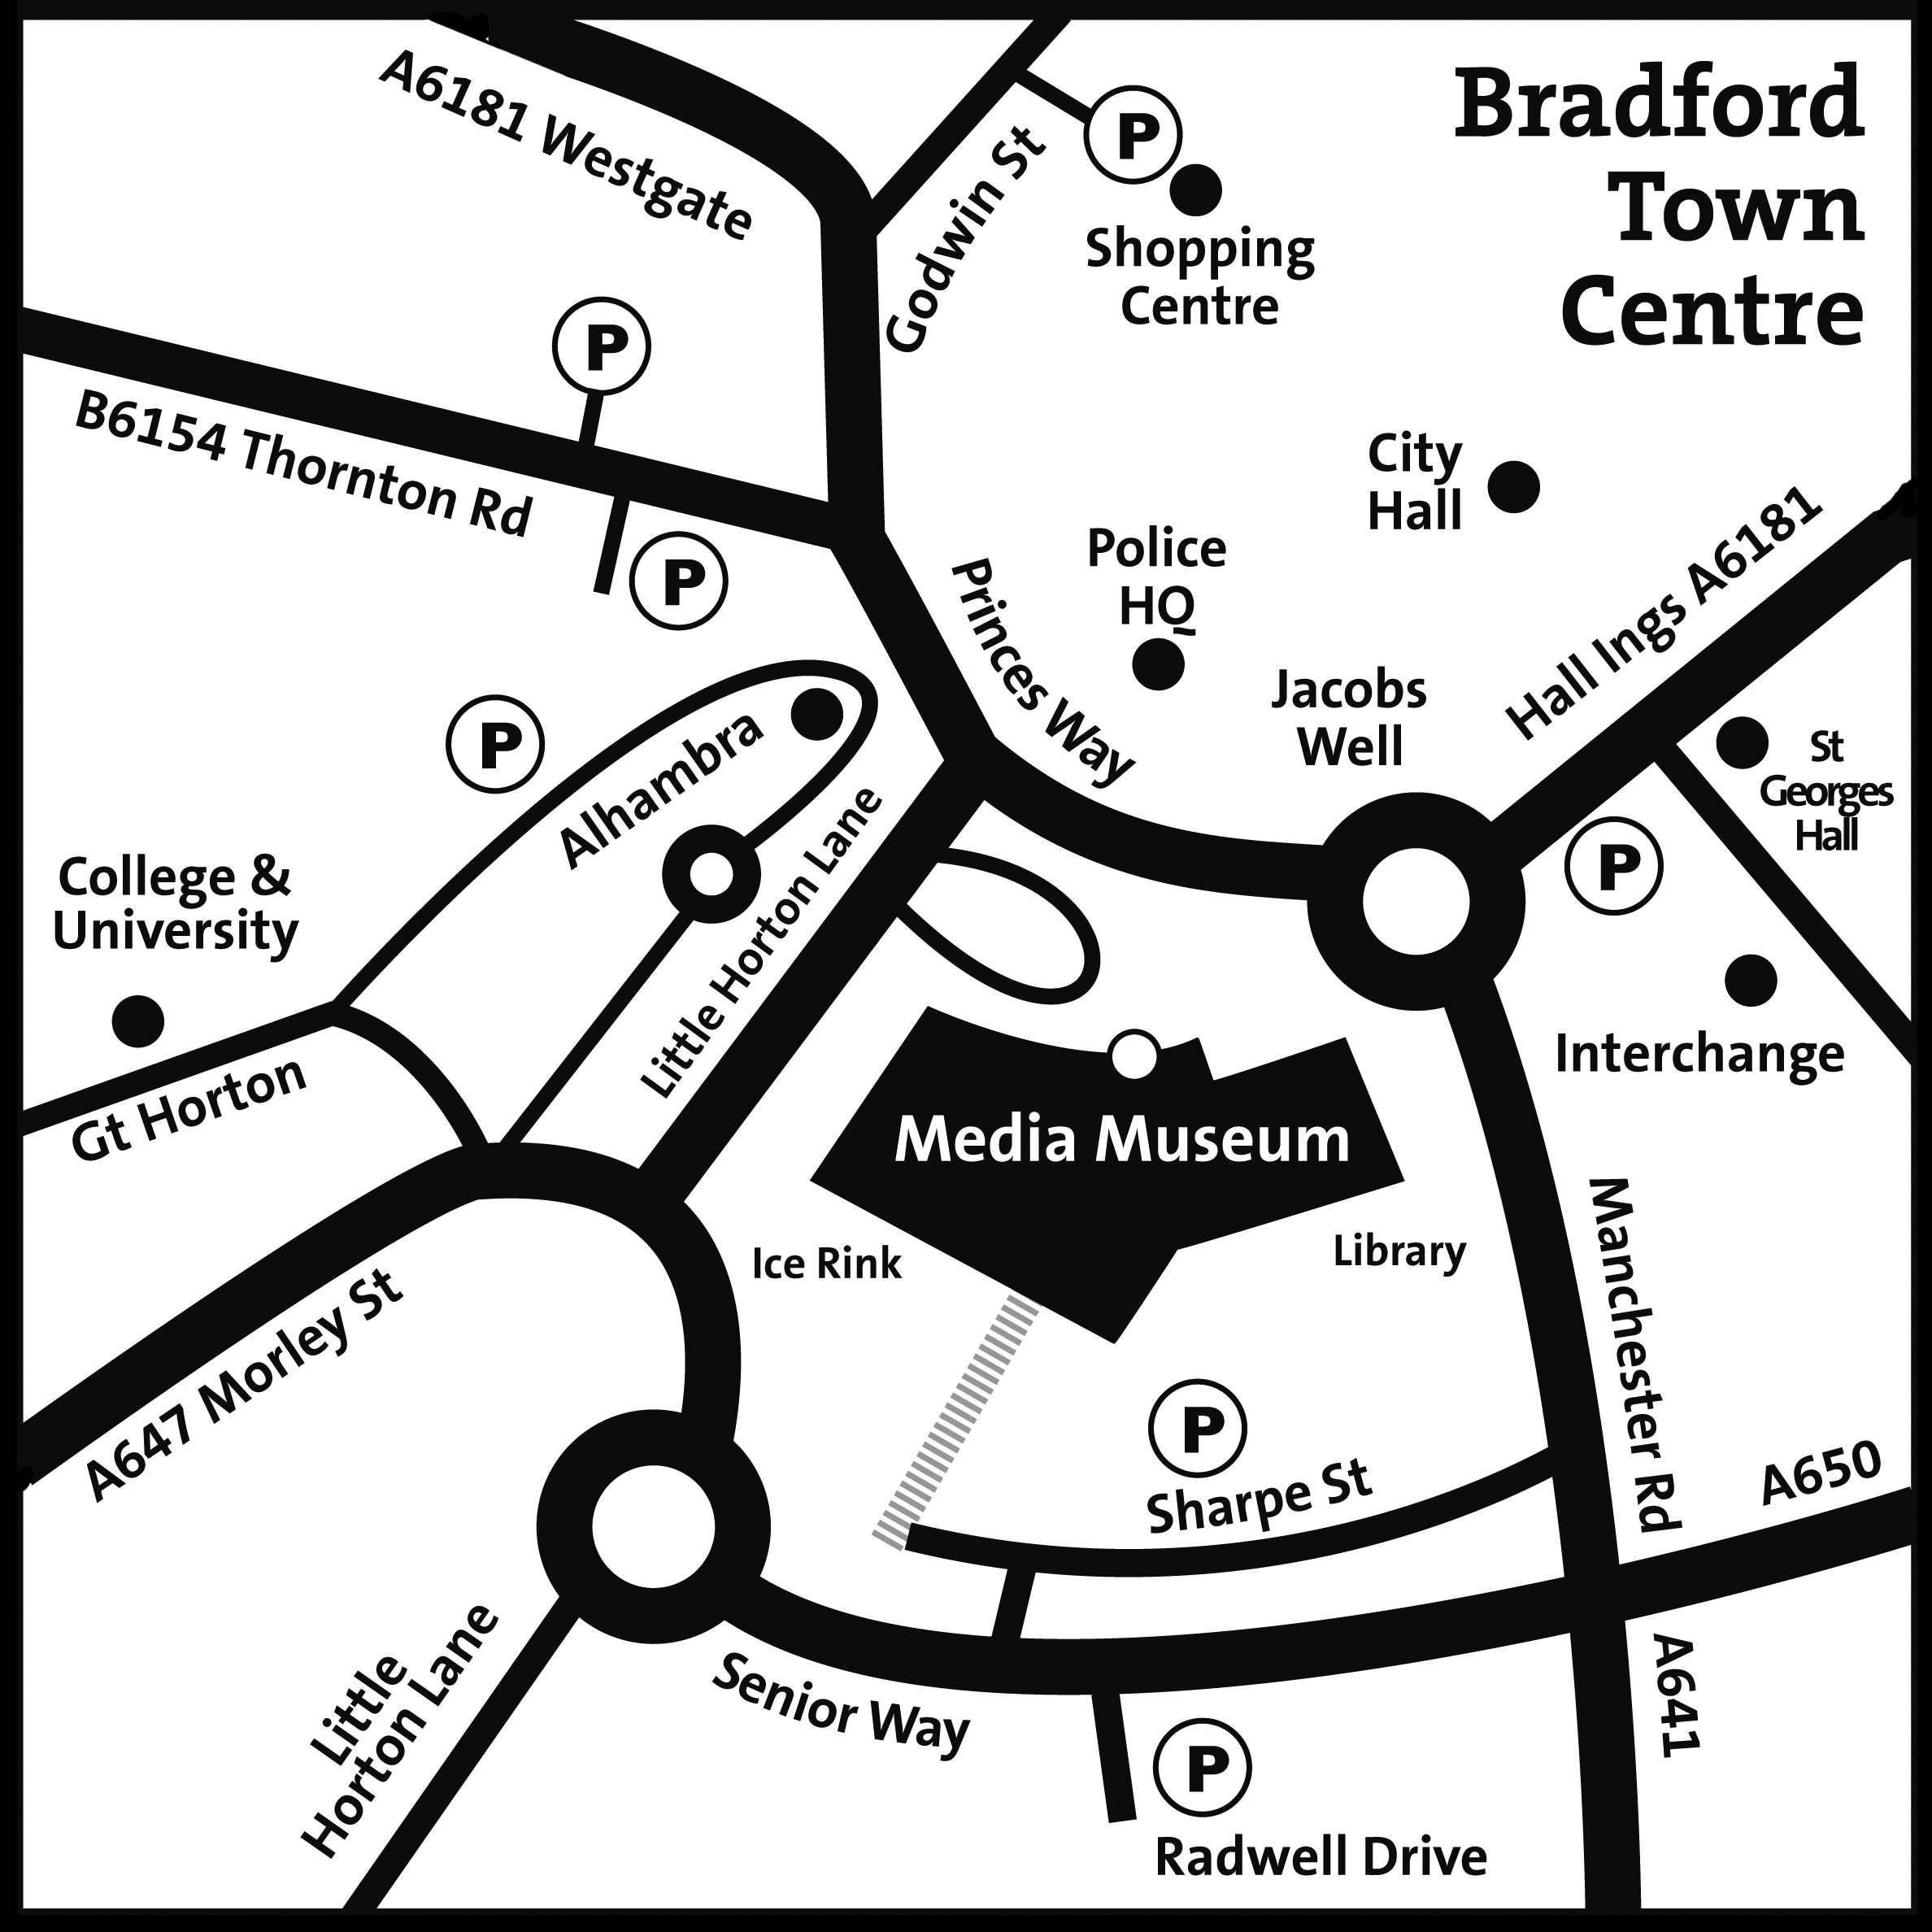

* P – indicates parking

How to find us:

The National Media Museum is in Bradford city centre. From the M62, leave the motorway at Junction 26, which leads onto the M606 with signposts leading directly into the city centre.

Coming from Leeds on the A647, follow the signs for Bradford. Coming into the City Centre, go straight on at the intersection with the Shipley-Airedale link road and straight on again at the traffic lights adjacent to the Telegraph & Argus offices on your left.

The Museum is situated on the Jacobs Well roundabout, adjacent to the Alhambra Theatre and opposite the main Police Station, with nearby Pay and Display car parks clearly signposted.

Public transport: Bradford Interchange station is five minutes’ walk away from the Museum with rail services towards Leeds and York, and towards Manchester and Blackpool. Bradford Forster Square station is also nearby with rail services towards Skipton, Ilkley and Leeds, and to London Kings Cross.

